PREVENTING INJURIES TO THE THROWING ARM

Do you know how fast the throwing arm is traveling to throw an 80-mph fastball?
Well, this is really a trick question, but the correct answer is 80-mph. Do you know the name of the muscles that have to slow down that arm traveling 80-mph? They, collectively, are called the rotator cuff. And, they may just be the most important muscles in a baseball player’s body.
Medical research focusing on baseball injuries has been a hot topic over the last 10 years. There are more players getting hurt than ever before. Surely, you’ve seen an increase in arm pain on your team. Ask your parents or coaches and they’ll tell you that the incidence is significantly higher vs. when they were children. Why? Well, that answer could be explained in one word…immobility. Kids move less now than they did 20 years ago. Twenty years ago, there was no Playstation, no home computers, and no cell phones. The kids played…and played and played. You would come home from school and play outside until your Mom called you in for dinner. Then, you would go out and play some more until your Mom called you in because it was getting dark outside. I was asked a few years ago to explain why so many kids are getting adult-style injuries. I said, “Let’s compare their days”. Kids come home from sitting 8 hours a day at school and sit at the computer, or playing his/her video games, or text messaging. Then, he/she eats dinner sitting down. Then, after dinner, does his/her homework sitting down, then, finishes the night with watching television…sitting down. The average adult sits for 8-10 hours a day at work. Then, he/she comes home and sits to eat his/her dinner. Then, due to fatigue from a long day, sits and watches television until its bedtime. They look a lot alike, don’t they?
Back to the medical research…research has demonstrated what movements work what muscles better than any other movement. Based on this research, we, at OrthoRehab Specialists, Inc., have created a preventative program to reduce the frequency of throwing injuries. Now, this program is designed for the throwing athlete with no arm pain. If you have arm pain, then, please see a doctor and get a referral for Physical Therapy so that your individual problems can be addressed. To get the most out of this program, perform it every other day (except #5 – perform 3x/day, every day for the most benefit). Start off with one set of ten repetitions and build up to three sets of ten repetitions. Rest no more than 30 seconds between sets. Perform the exercises in this order:

- 90/90 THORACIC ROTATION STRETCH – Assume a left side-lying position with the right hip & knee flexed to 90º & the left leg straight. Rest the right knee on a batting helmet, medicine ball, soccer ball, or foam roll. Rotate the trunk & your head to the right. Brace your abdominals. Take your left hand & push actively towards the ceiling. With the right arm, reach upward & outward. Hold for 2 seconds, and then return to starting position. Repeat 10x.

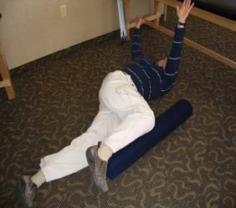

- PUSH-UP PLUS - Assume normal starting position for a push-up. Push up to the top of the motion. When at the top push up a little higher (do Not lift your butt up!!!).

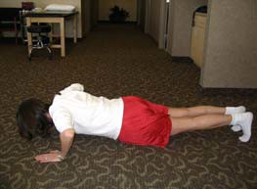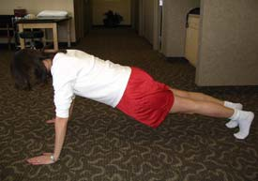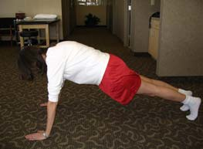

- ROWS – Place a piece of theraband or tubing in the door between belly & nipple height. Start with your arms straight out in front of you with your palms facing each other. Pull your elbows behind you past your sides and squeeze your shoulder blades together.

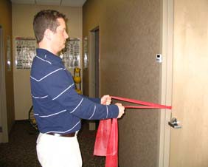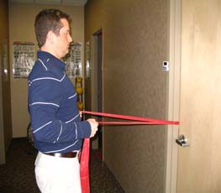

- T’s WITH THUMBS UP – Lie on your belly on the floor with your arms directly out to your sides and your thumbs pointed up. Tighten belly, squeeze shoulder blades, then lift arms up towards ceiling. Lower slowly.

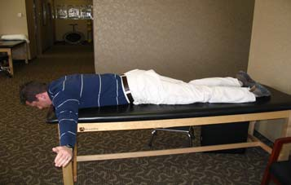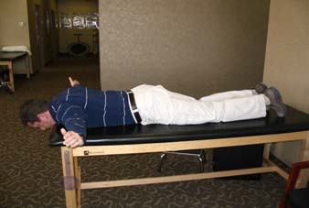

- PRONE SHOULDER EXTENSION with EXTERNAL ROTATION – Begin by lying on your belly with your arm hanging off of the side of the table, couch, or bed. Keep the elbow straight
& the palm facing forward. Slowly lift the arm behind you until your arm is parallel to the floor
& next to your hip. Lower slowly.

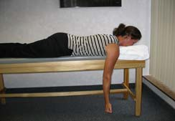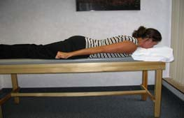

- SLEEPER STRETCH – Lie on your non-throwing side, with your non-throwing shoulder directly in line with your throwing shoulder (do not lean back). Using 2 fingers, gently push your arm down until you feel a stretch in the back of your shoulder. Keep your head and shoulders resting. Avoid pain in the armpit. Perform 3 repetitions, holding for 30 seconds at a 90 degree angle. Then, repeat with the arm at a 70 degree angle. Perform 3x per day (morning, after throwing, before bed), every day.

